Estimated time to complete this lab: **60 minutes.**

Create a React Application named “cricketapp” with the following components:

1. ListofPlayers

* Declare an array with 11 players and store details of their names and scores using the map feature of ES6Filter the players with scores below 70 using arrow functions of ES6.

1. IndianPlayers

Display the Odd Team Player and Even Team players using the Destructuring features of ES6Declare two arrays T20players and RanjiTrophy players and merge the two arrays and display them using the Merge feature of ES6

Display these two components in the same home page using a simple if else in the flag variable.

Directory:

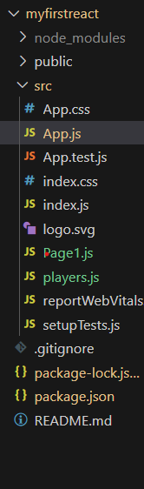

**Code for App.js:**

import React from 'react'

import Page1 from './Page1'

const App = () => {

  return (

   <>

<Page1 flag={1} />

   </>

  )

}

export default App

**Code for Page1.js:**

import React from 'react'

import players from './players'

const Page1 = ({flag}) => {

if(flag===1) {return (

    <>

    <h1>List of All Players</h1>

    {

        players.map((player, index) => (

            <div key={index}>

            <p>{player.name}</p>

            </div>

        ))

    }

    <h1>Playes of score less than 70</h1>

    {

        players.filter(player => player.score < 70).map((player, index) => (

            <div key={index}>

            <p>{player.name} - {player.country} - {player.score}</p>

            </div>

        ))

    }

    </>

  )

}

  else return (

    <>

    <h1>List of odd players</h1>

    {

        players.filter((_, index) => index % 2 === 1).map((player, index) => (

            <div key={index}>

            <p>{player.name} - {player.country} - {player.score}</p>

            </div>

        ))

    }

    <h1>List of even players</h1>

    {

        players.filter((_, index) => index % 2 === 0).map((player, index) => (

            <div key={index}>

            <p>{player.name} - {player.country} - {player.score}</p>

            </div>

        ))

    }

    <h1>List of Indian Players</h1>{

        players.filter(player => player.country === "India").map((player, index) => (

            <div key={index}>

            <p>{player.name} - {player.country} - {player.score}</p>

            </div>

        ))

    }

    </>

  )

}

export default Page1

**Code for Players.js:**

const players = [

  { name: "Virat Kohli", country: "India", score: 92 },

  { name: "Rohit Sharma", country: "India", score: 75 },

  { name: "Shubman Gill", country: "India", score: 68 },

  { name: "Ravindra Jadeja", country: "India", score: 55 },

  { name: "Jasprit Bumrah", country: "India", score: 70 },

  { name: "Steve Smith", country: "Australia", score: 88 },

  { name: "Kane Williamson", country: "New Zealand", score: 95 },

  { name: "Joe Root", country: "England", score: 77 },

  { name: "Ben Stokes", country: "England", score: 66 },

  { name: "Mitchell Starc", country: "Australia", score: 60 },

  { name: "David Warner", country: "Australia", score: 80 }

];

export default players;

**Output:**

**If(flag==1)**

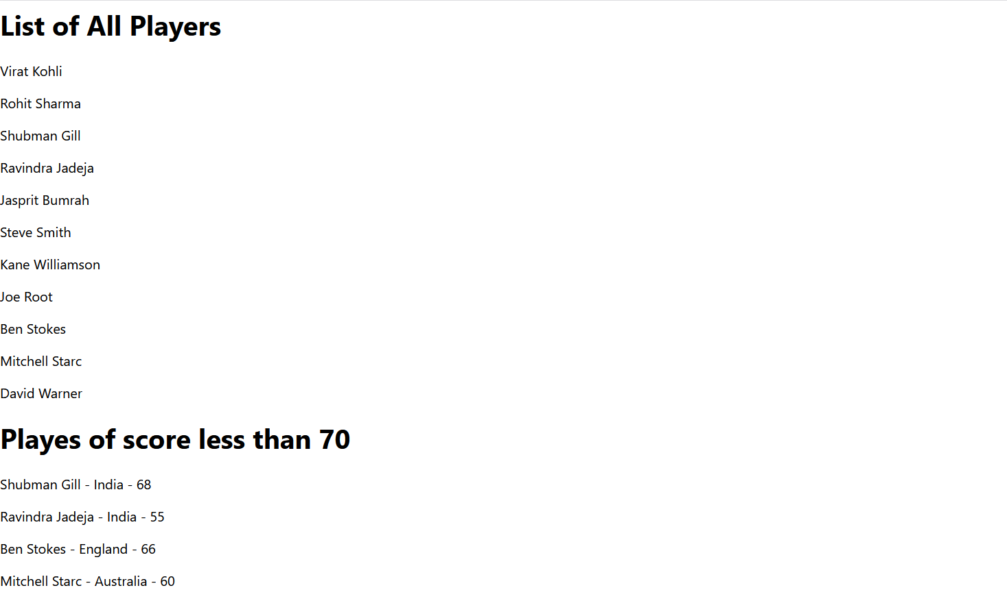

**If(flag==0)**

